The differences of hypertensive guidelines :Application of Clinical Trials to Routine Practice
:Updates in Treating Hypertension
Supachai Tanomsup MD,FRCPC,FACC
The differences of hypertensive guidelines
Hypertension is a major risk factor for the development of CVD. The evidence linking untreated
hypertension to increased cardiovascular morbidity is undisputed. However, literature surveys continue to report
suboptimal population based management of hypertension. For example, in the 1999–2002 National Health and
Nutrition Examination Survey of non-Hispanic whites, 62.9% of patients with hypertension were aware of their
diagnosis, 48.6% were receiving treatment, and only 29.8% had their hypertension controlled (1). Published
guidelines differ regarding the age at which blood pressure assessment should commence. The recommendations
of the seventh report of the Joint National Committee on Prevention, Detection, Evaluation, and Treatment of High
Blood Pressure(2), which recommends screening beginning at 18 years of age.

Controversy remains as to the optimal role of specific classes of antihypertensive medication
in the treatment of hypertension.For example, the seventh report of the Joint National Committee on Prevention,
Detection, Evaluation, and Treatment of High Blood Pressure and the European Society of Hypertension differ with
regard to preferred agents for initial monotherapy. This area of inquiry continues to evolve. Individual physicians may
reasonably choose 1 initial strategy over another and still comply with published guidelines, If blood pressure is not
controlled despite antihypertensive medication, clinicians should assess possible reasons for poor control
(e.g., patient adherence to recommended treatments) before changing the choice or dose of medication

Antihypertensive Drug Treatments

For primary prevention of hypertension, particularly in association with CAD and IHD, the choice of drugs remains controversial. There was a general consensus that it is the amount of blood pressure reduction, rather than the choice of any particular antihypertensive drug or class of drugs, that is the major determinant of reduction of cardiovascular risk. The group did agree, however, that there is sufficient evidence from comparative clinical trials to support the use of an angiotensin-converting enzyme (ACE) inhibitor (or ARB), a calcium-channel blocker (CCB), or a thiazide-type diuretic as first-line therapy, supplemented by a second drug if blood pressure control is not achieved with monotherapy .Most patients will require ≥ 2 drugs to reach goal, and when the blood pressure is > 20/10 mm Hg above goal, 2 drugs should usually be used from the outset.
Beta-blockers were not included at all in the recommendations for primary prevention, based on negative evidence from the ASCOT-BPLA,(3) CONVINCE (4),and MRC(5) trials, and from a 2005 meta-analysis.(6) indicate that, in patients with uncomplicated hypertension, compared with other antihypertensive agents, first-line therapy with beta-blockers is associated with an increased risk of stroke, especially in the elderly, with no benefit at all for the endpoints of all-cause mortality and cardiovascular morbidity/mortality. A critical review (7) of the evidence in patients with uncomplicated hypertension, the authors found a paucity of data or absence of evidence to support use of beta-blockers as monotherapy or as first-line agents. Given the increased risk of stroke, their "pseudo-antihypertensive" efficacy (failure to lower central aortic pressure), lack of effect on regression of target end organ effects like left ventricular hypertrophy and endothelial dysfunction, and numerous adverse effects, they concluded that “the risk benefit ratio for beta-blockers is not acceptable for this indication.” However, in patients with uncontrolled hypertension on various other antihypertensive agents, as well as in those with complicated hypertension, “beta-blockers should be considered in the armamentarium of treatment.”

In asymptomatic post-MI patients, a beta-blocker is a more appropriate choice for secondary prevention for ≥ 6 months after the infarction and is the drug of first choice if the patient has angina pectoris, the guidelines note.
For secondary prevention in individuals with so-called compelling indications, such as IHD, chronic kidney disease, or recurrent stroke, not all drug classes have been proven to confer optimal benefit. Patients who have had an MI or who have heart failure have improved outcomes with ACE inhibitor therapy, consistent with the actions of these drugs in preventing or retarding atherogenesis, although the VALUE(8) and ALLHAT(9)] studies failed to show any particular benefit for the ARB valsartan and the ACE inhibitor lisinopril, respectively, over comparator drugs of other classes.
There is also continuing debate over whether there are "class effects" for antihypertensive drugs or whether each drug must be considered individually. It is reasonable to assume that there are class effects for thiazide-type diuretics, ACE inhibitors, and ARBs, which have a high degree of homogeneity in their mechanisms of action and side effects. It is equally clear that there are major differences between drugs within more heterogeneous classes of agents, such as beta-blockers or CCBs,

Global Cardiovascular and Metabolic Risk Assesment
In the last few years there has been more of an emphasis on total cardiovascular risk in the diagnosis and management of hypertension, because the vast majority of hypertensive patients have multiple cardiovascular risk factors. Given strong evidence that hypertension and metabolic risk factors potentiate each other (Figure 1), leading to a total risk greater than the sum of the individual components, experts now recommend treating BP in the context of global cardiovascular risk.
For example, new hypertension guidelines from the European Society of Cardiology (ESC) suggest that all patients should be classified not only by grade of hypertension but also by total cardiovascular risk based on the presence of risk factors, organ damage, and disease.(10) As for decisions on treatment strategies (initiation of drug treatment, target for treatment, need for lipid-lowering therapy, and need for combination antihypertensive therapy), all depend on initial level of risk.
Usually, total risk is expressed as the absolute risk of having a cardiovascular event within 10 years. However, because of its heavy dependence on age, absolute total cardiovascular risk can be low in young patients with hypertension even when they have additional risk factor . In younger subjects, the new ESC guidelines suggest that treatment decisions be guided by quantification of relative risk, i.e., the increase in risk in relation to average risk in the population. As shown in Figure 1, the term “added risk” is used to emphasize that in all categories relative risk is greater than average risk.

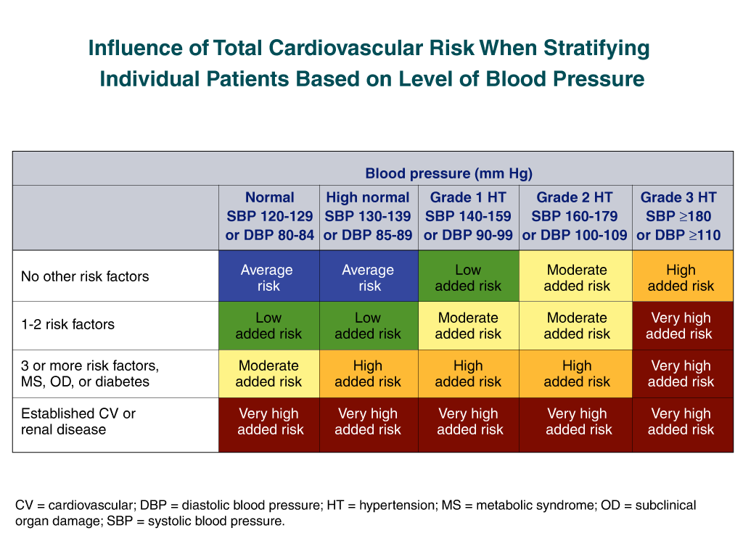
Figure 1 Total Cardiovascular Risk Stratification

BP Management in Special Populations
- Diabetes Mellitus
Epidemiological analyses and randomized clinical trials have demonstrated the impact of elevated blood pressure as a risk factor for both microvascular and macrovascular disease in diabetes. As a result, many have argued that blood pressure management is the most critical aspect of the care of the patient with diabetes. In 2007, the American Heart Association and the American Diabetes Association published a statement on the primary prevention of cardiovascular disease in individuals with diabetes mellitus.(11) In regards to treating BP in these patients,recommendations include:

- 1.1 Patients with diabetes should be treated to a systolic blood pressure <130 mm Hg and a diastolic blood pressure <80 mm Hg.
- 1.2 All patients with diabetes and hypertension should be treated with a regimen that includes either an ACE inhibitor or an ARB. If one classis not tolerated, the other should be substituted. Other drug classes demonstrated to reduce cardiovascular disease events in patients with diabetes (beta-blockers, thiazide diuretics, and calcium channel blockers) should be added as needed to achieve blood pressure targets.
- 1.3 If ACE inhibitors, ARBs, or diuretics are used, renal function and serum potassium levels should be monitored with in the first 3 months.If levels are stable, follow-up could occur every 6 months thereafter.
- 1.4 Multidrug therapy generally is required to achieve blood pressure targets.
- 1.5 Patients who do not achieve target blood pressure despite multidrug therapy should be referred to a physician specializing in the care of patients with hypertension.
2. Population with kidney disease.
Cardiovascular and renal diseases share many of the same risk factors; thus preservation of kidney function might simultaneously protect the heart and, conversely, addressing cardiovascular risk factors might safeguard the kidney. Recently, the European Society of Hypertension published a consensus statement reviewing the kidney and cardiovascular risk and implications for management.(12) One important conclusion, based on the evidence, is that intervention may be appropriate even in individuals with high-normal BP if they already have early renal and/or cardiovascular risk markers. Overall, the authors noted, thresholds for starting antihypertensive therapy are gradually falling, whereas awareness of the need for an early intervention in patients at high risk of developing renal damage and simultaneously cardiovascular disease is growing.
Also, in regards to renal disease, the new ESC hypertension guidelines include some new recommendations. First, the list of renal markers of organ damage has been expanded, to include estimates of creatinine clearance by the Cockroft-Gault formula or of glomerular filtration rate by the Modification of Diet in Renal Disease formulae, because of evidence that these estimated values are a more precise index of the cardiovascular risk accompanying renal dysfunction. Both estimates help to detect mild impaired renal function in the face of serum creatinine values that are still in the normal range. Second, microalbuminuria is now considered an essential component in the assessment of organ damage because its detection is easy and relatively inexpensive.

3. Ischemic Heart Disease

Hypertension is an independent risk factor and as an origin of the disease state formation mechanism of ischemic heart disease. The increase of oxidative stress by the activation of renin-angiotensin system and NAD (PH) oxidase, which is related to the disease state of hypertension, brings about the generation of hemodynamic external force to the vessel wall and left ventricular hypertrophy, which further bring about coronary artery sclerosis extension and atheroma instability. to be related to the crisis of acute coronary syndrome and ischemic heart disease. Based on the results of recent large-scale clinical trials on hypertension treatment, it is explained that sufficient control of blood pressure is vital to the prevention of ischemic heart disease crisis. It has been reported that the crisis of ischemic heart disease is rapidly increased with multiple risk factors such as obesity, hyperlipidemia and glucose tolerance . A comprehensive approach including not only the management of hypertension, but also the control of other risk factors, is required.(13)
Awareness Treatment and Control of Hypertension
Finally, the prevalence of hypertension continues to rise across the world, and most patients who receive medical intervention are not adequately treated to goal. Recently, representatives of nine international health-care organizations reviewed the barriers to more effective blood pressure control and proposed actions to address them. Bakris et al. concluded that tackling the global challenge of hypertension will require partnerships among multiple constituencies, including patients, healthcare professionals, industry, media, healthcare educators, health planners, and governments(22)
Additionally, the working group asks healthcare professionals to act locally to improve blood pressure goal rates. The Working Group identified five core actions that should be rigorously implemented by practitioners and targeted by health systems throughout the world: 1) detect and prevent high blood pressure; 2) assess total cardiovascular risk; 3) form an active partnership with the patient; 4) treat hypertension to goal; and 5) create a supportive environment. The authors concluded, “These actions should be pursued with vigor in accordance with current clinical guidelines, with the details of implementation adapted to the economic and cultural setting.”

References
- Centers for Disease Control and Prevention (CDC). Racial/ethnic disparities in prevalence, treatment, and control of hypertension: UnitedStates, 1999-2002. MMWR Morb Mortal Wkly Rep. 2005;54:7–9.
- Chobanian AV, Bakris GL, Black HR, et al. Seventh report of the Joint National Committee on Prevention, Detection, Evaluation, and Treatment of High Blood Pressure. Hypertension. 2003;42:1206 –52.
- Dahlöf B, Sever PS, Poulter NR, et al; ASCOT Investigators. Prevention of cardiovascular events with an antihypertensive regimen of amlodipine adding perindopril as required versus atenolol adding bendroflumethiazide as required, in the Anglo-Scandinavian Cardiac Outcomes Trial-Blood Pressure Lowering Arm (ASCOT-BPLA): a multicenter randomised controlled trial. Lancet. 2005;366:895-906.
- Black HR, Elliott WJ, Grandits G, et al; CONVINCE Research Group. Principal results of the Controlled Onset Verapamil Investigation of Cardiovascular End Points (CONVINCE) trial. JAMA. 2003;289:2073-2082.
- MRC Working Party. Medical Research Council trial of treatment of hypertension in older adults: principal results. BMJ 1992;304:405-412
- Lindholm LH, Carlberg B, Samuelsson O. Should beta blockers remain first choice in the treatment of primary hypertension? A meta-analysis. Lancet. 2005;366:1545-1553.
- Bangalore S, Messerli FH, Kostis JB, Pepine CJ. Cardiovascular protection using beta-blockers: A critical review of the evidence. J Am Coll Cardiol 2007;50:563-72
- Julius S, Kjeldsen SE, Weber M, et al; VALUE Trial Group. Outcomes in hypertensive patients at high cardiovascular risk treated with regimens based on valsartan or amlodipine: the VALUE randomised trial. Lancet. 2004;363:2022-2031
- ALLHAT-Officers and Coordinators for the ALLHAT Collaborative Research Group. Major outcomes in high-risk hypertensive patients randomized to angiotensin-converting enzyme inhibitor or calcium channel blocker vs diuretic: the Antihypertensive and Lipid-Lowering Treatment to Prevent Heart Attack Trial (ALLHAT). JAMA 2002;288:2981-2997
- Mancia G, De Backer G, Dominiczak A, et al. 2007 Guidelines for the management of arterial hypertension: The Task Force for the Management of Arterial Hypertension of the European Society of Hypertension (ESH) and of the European Society of Cardiology (ESC). Eur Heart J 2007;28:1462-536.
- Buse JB, Ginsberg HN, Bakris GL, et al. Primary prevention of cardiovascular diseases in people with diabetes mellitus: a scientific statement from the American Heart Association and the American Diabetes Association. Circulation 2007;115:114-26.
- Ruilope L, Kjeldsen SE, de la Sierra A, et al. The kidney and cardiovascular risk – implications for management: a consensus statement from the European Society of Hypertension. Blood Press 2007;16:72-9.
- Rosendorff C, Black HR, Cannon CP, et al. Treatment of hypertension in the prevention and management of ischemic heart disease: A scientific statement from the American Heart Association Council for High Blood Pressure Research and the Councils on Clinical Cardiology and Epidemiology and Prevention. Circulation. 2007;115:2761-2788.
- Bakris G, Hill M, Mancia G,et al. Achieving blood pressure goals globally: five core actions for health-care professionals.A worldwide call to action.J Hum Hypertens 2007]

